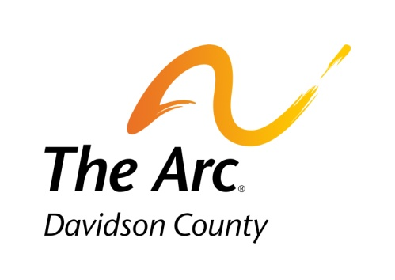**2025 Summer Camp**

The Arc of Davidson County, Inc. is partnering with Davidson Parks and Recreation to offer an inclusive Summer Camp.

**All school-age children with an IEP are eligible.**

The Arc employees receive training on supporting children with intellectual and developmental disabilities and will work in partnership with all campers and staff to ensure a fun and safe experience for every child.

Please complete and return the registration form. Children are not required to attend every week, nor every day within a week. **Be sure to detail any special information about your child on the back of the registration sheet.**

Camp days and hours: Monday-Thursday, 7:30am-2pm

July 7th-July 24th

$20 per week per child

Midway Elementary School

Return to:

The Arc of Davidson County, Inc.

1900 S. Main St.

Lexington NC 27292

Attention: Lyndsay Martin

For more information, call: 336.248.2842

[www.arcdavidson.org](http://www.arcdavidson.org)

